Technical Story Card
Revision History
Version No. | Date | Prepared by / Modified by | Significant Changes
1 | 28th July 2022 | Ashvini Vilas Shastri
 |  | Yarram Srilatha
M
Vijaya Lakshmi
 |  | Kiran Basanagouda Patil

Glossary
Abbreviation | Description
BSC | Business Story Card
TSC | Technical Story Card

Table of Contents
1 Introduction 2
2 Scope Of Change 2
3 List of impacted modules 2
4 Design and Detailed technical updates 4
4.1 Process model 4
4.1.1 Entity diagram 4
4.1.2 Class diagram 10
4.1.3 Sequence diagram 11
5.References……………………………………………………………………………………..12

Introduction
Exam Portal is a web application that provides professors/admin a user-friendly platform to host quizzes/test based on different categories. Admin can add/delete/update categories and quizzes and normal user who is taking the test can see all available quizzes and can view different quizzes based on the category after login.
There are two types of users that are available in Exam Portal app :
- Admin – to be used by the Professor/who is registered as admin in database
- Student/normal user

Scope of Change
Change will not be entertained and whatever specifications mentioned in this document is final.

List of impacted modules
All the functional modules are created from scratch.

Design and Detailed technical updates

Process model

Entity diagram

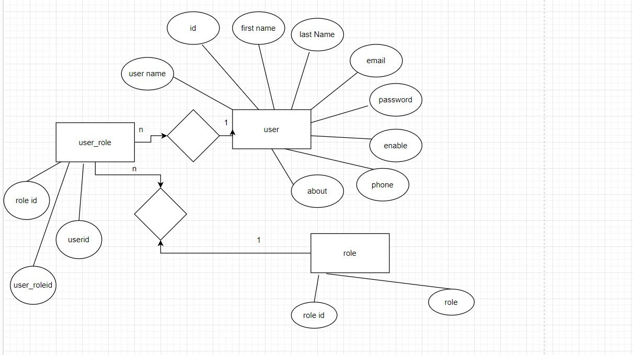

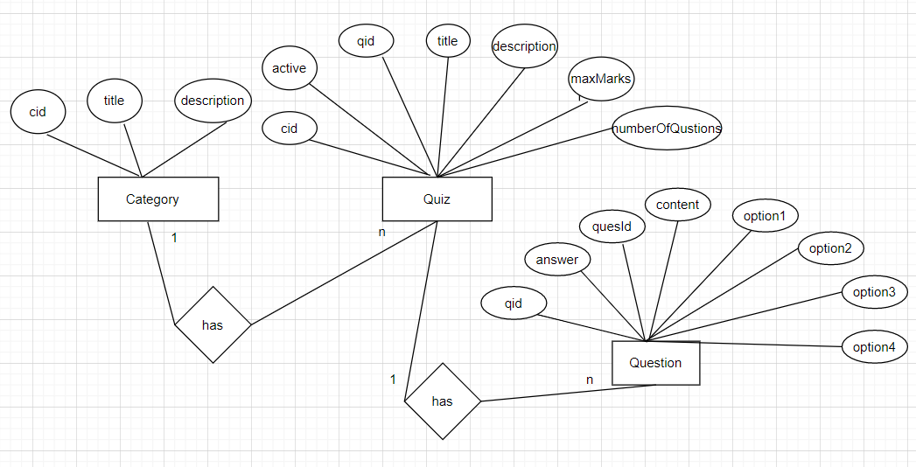
Brief Description | Registration
Basic Flow | This use case describes how a user register in to the system  - The user has to register himself into the system.  - After the successful registration, he will get a success message.  - The following information is required during registration.  - Username  - User password  - First name  - Last Name  - Email address  - Phone number
Alternate Flow | - The system will validate the information provided. If any invalid data found, the input form will be redirected with error message.
Validation | - Username should be unique and not empty  - Password cannot be empty  - All fields are mandatory fields
Pre-Conditions | User should have network access and Browser with latest updates.
Post-Conditions | Success message will be displayed.

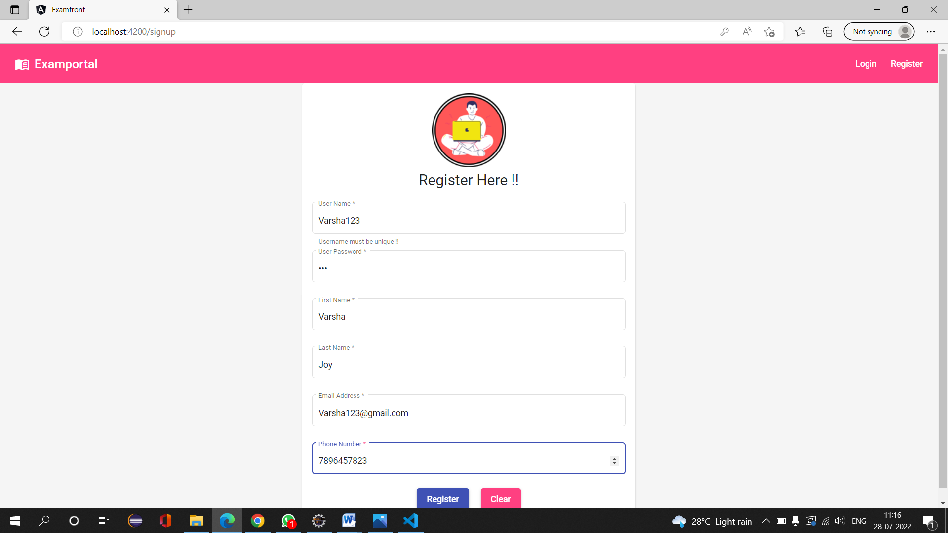

Brief Description | Login
Basic Flow | This use case describes how a user log-in in to the system  - The user/ admin has to register himself into the system.  - After the successful login, user will be taken to the appropriate landing page.  - The following information is required to login.  - username  - password
Alternate Flow | - The system will validate the credentials provided. If credentials are invalid, login form will be redirected again with error message.
Validation | - Valid username  - Valid password
Pre-Conditions | User should have network access and Browser with latest updates.
Post-Conditions | Landing page has to be displayed.

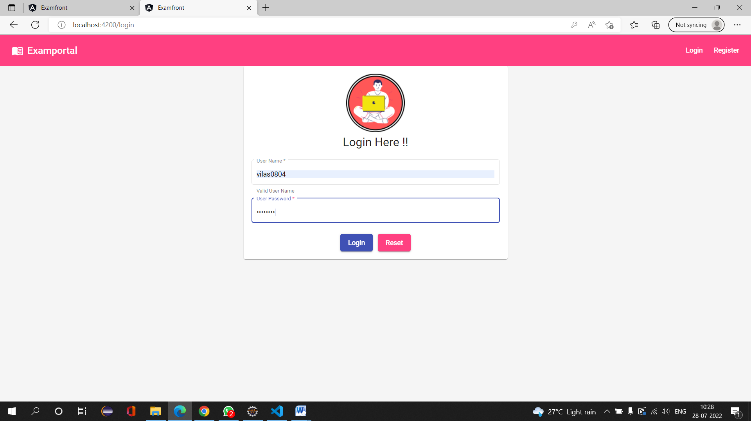

Brief Description | Add quiz category
Basic Flow | This use case describes how admin can add quiz category  The admin will add quiz category  The following information is required  - Title  - Description
Alternate Flow | If title is not written then admin will get error message
Pre-Conditions | User should have network access and Browser with latest updates.
Post-Conditions | Not applicable

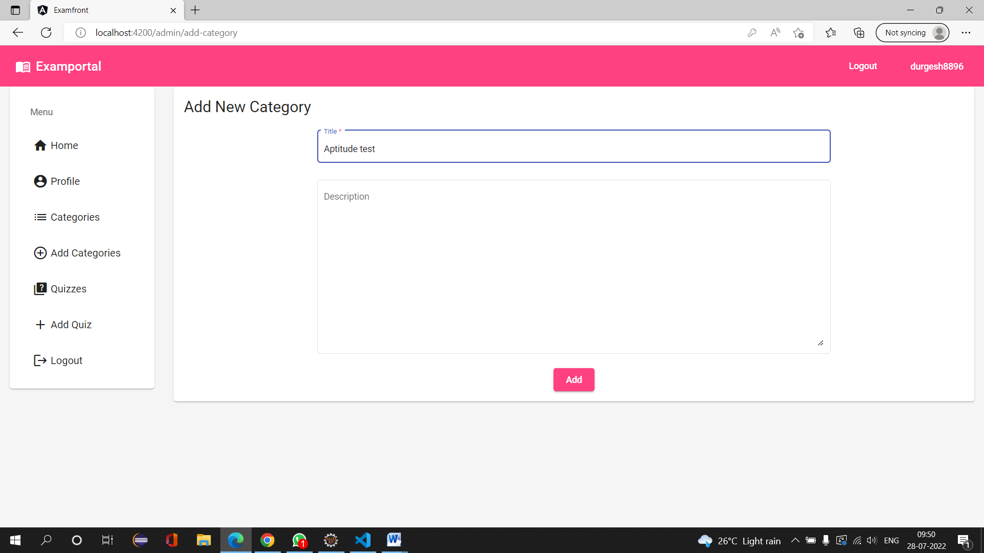

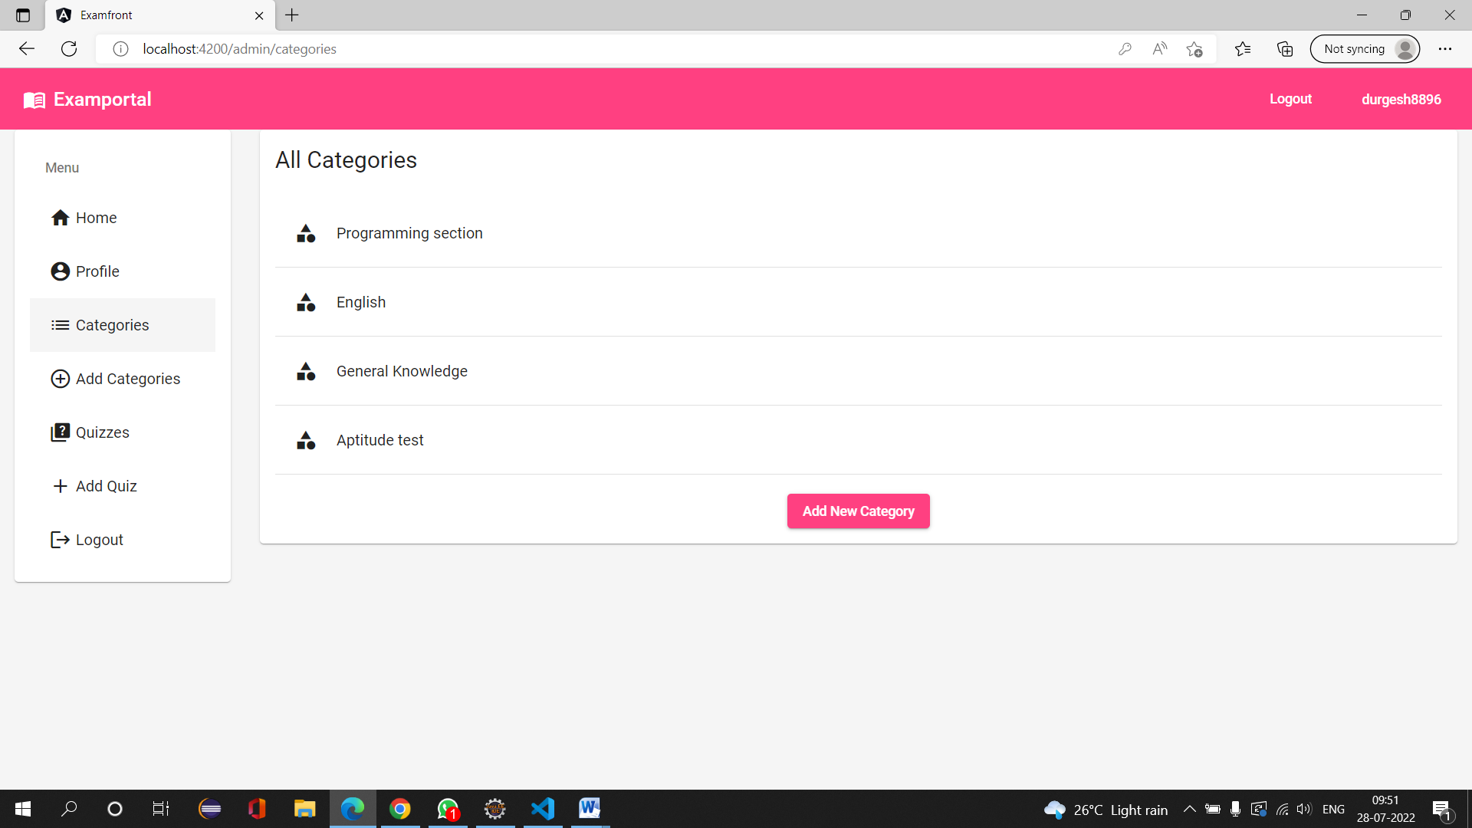

Brief Description | Add quiz questions
Basic Flow | This use case describes how admin can add quiz questions in particular category  The admin will add quiz questions in specific category  The following information is required  - Questions  - 4 options  - Correct answer
Alternate Flow | Not applicable
Validation | Not applicable
Pre-Conditions | User should have network access and Browser with latest updates.
Post-Conditions | Not applicable

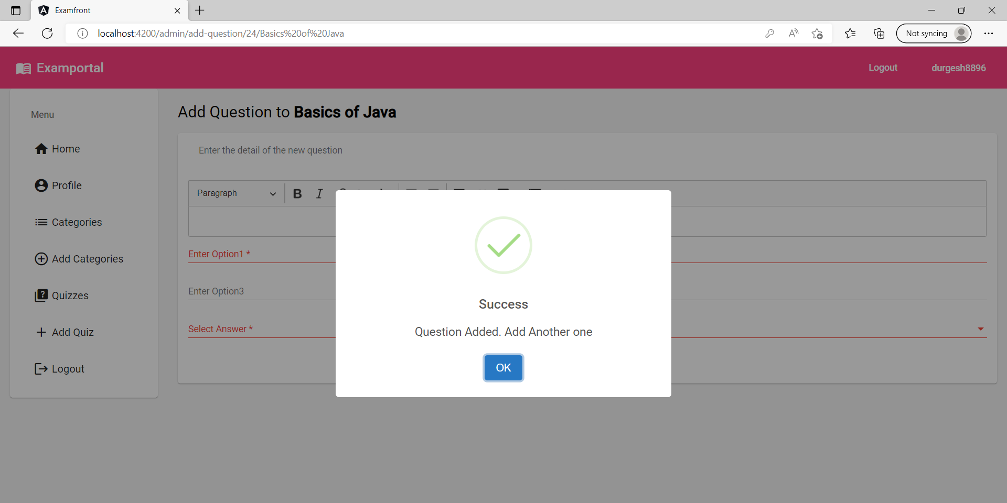

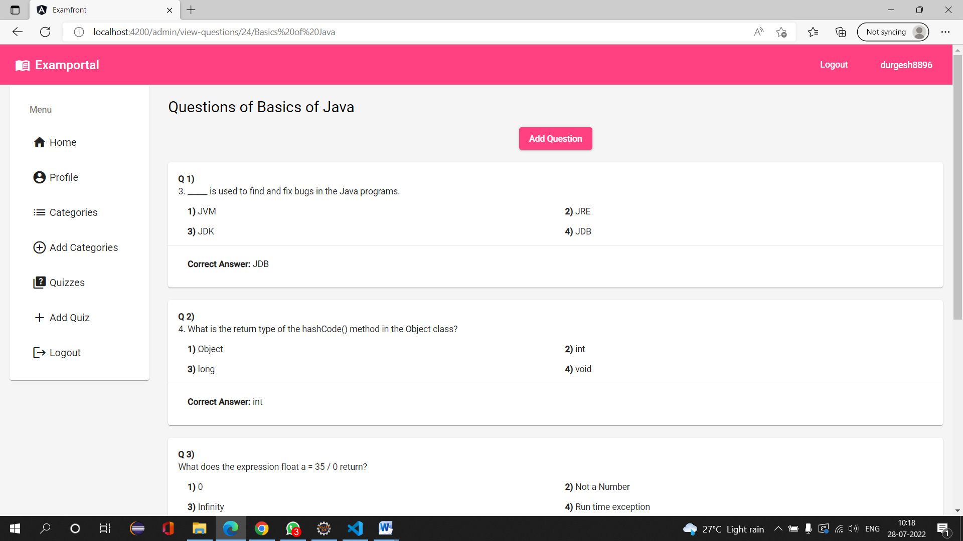
Brief Description | Available quizzes for user
Basic Flow | This use case describes where user can see all available quizzes.  The user can see different available quizzes and user can give quiz and after submitting the quiz user can see the scored marks.
Alternate Flow | Not applicable
Validation | Not applicable
Pre-Conditions | User should have network access and Browser with latest updates.
Post-Conditions | User can see the secured marks after submitting the quiz

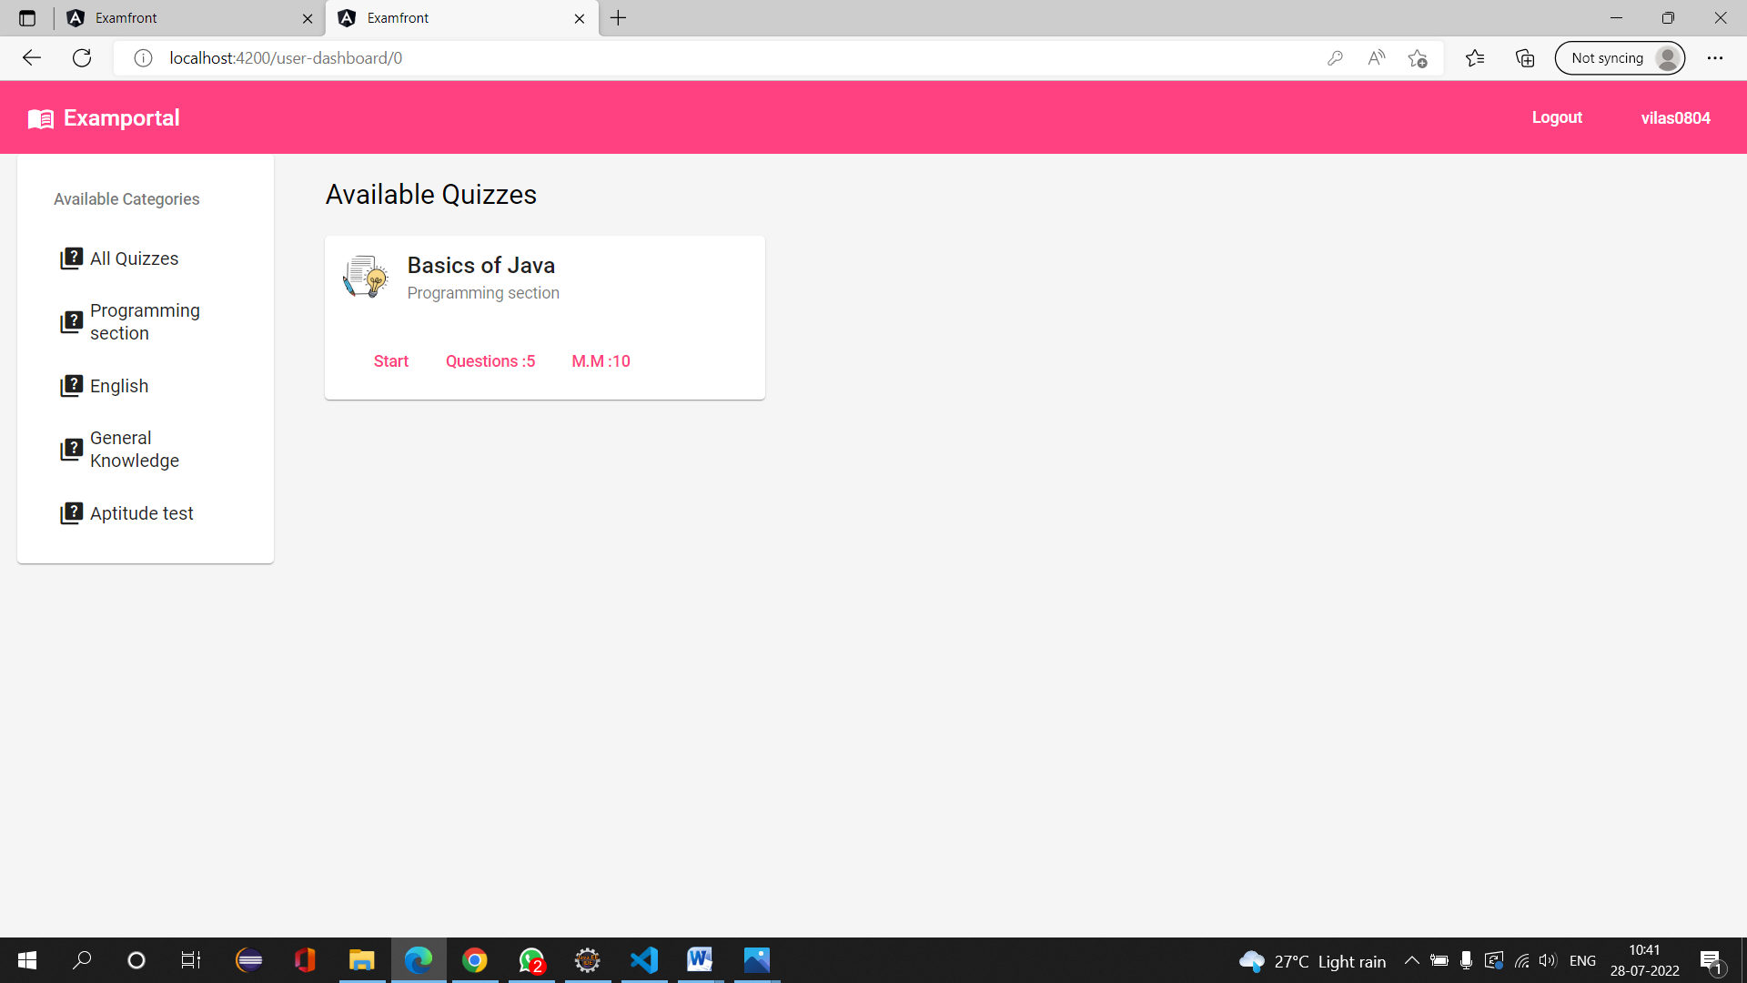

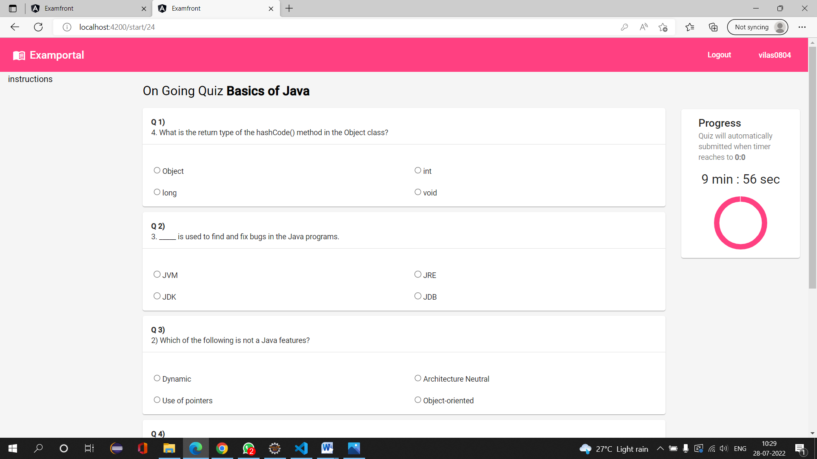

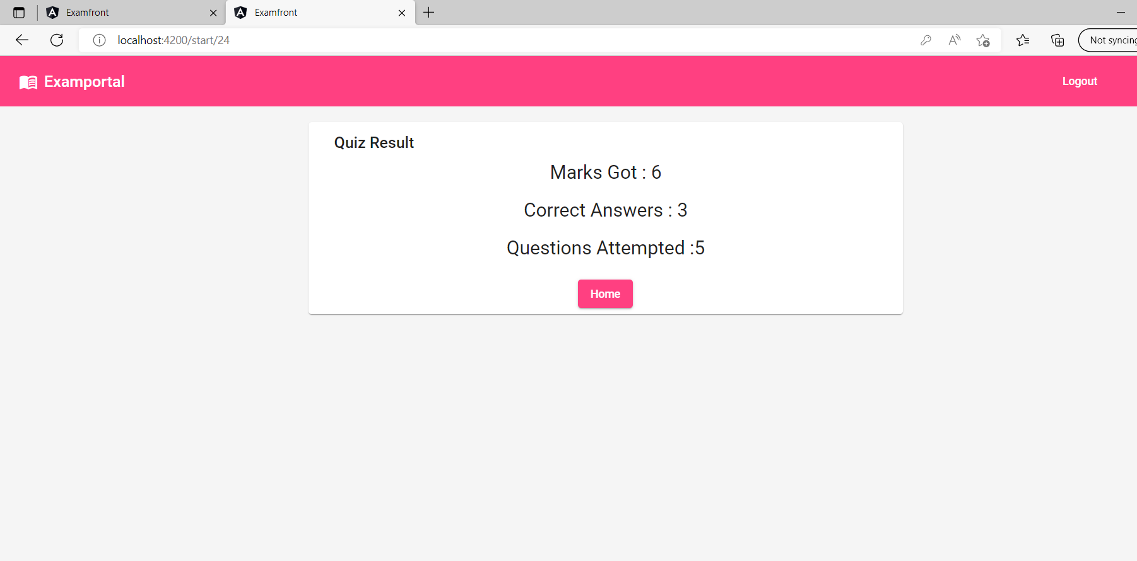

Class diagram

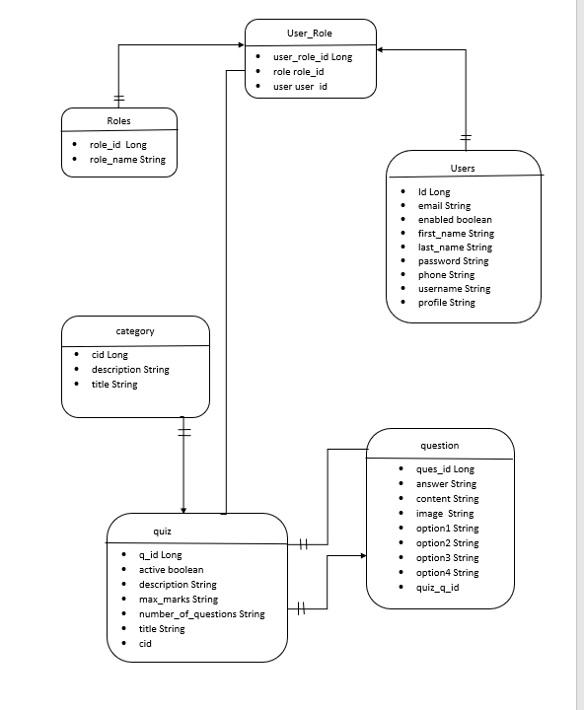

Sequence diagram

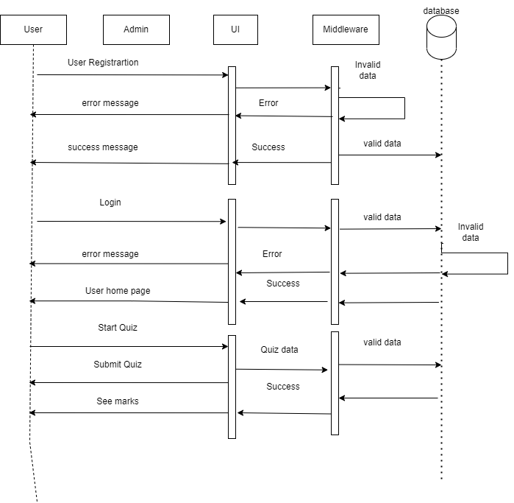

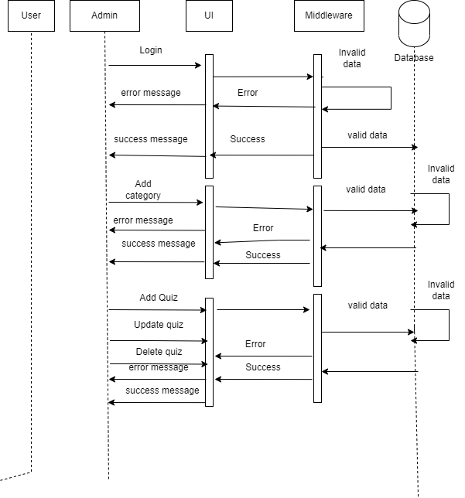

5 References

[1] Bobde S, Chaudhari S, Golguri J, Shahane R (2017) Web based online examination system. Global Res Develop J Eng 2(5):58–61

[2] Younis MI, Hussein MS (2015) Construction of an online examination system with resumption and randomization capabilities. Int J Comput 4(2):62–82

